TinkerCad 3D Printer Design Files
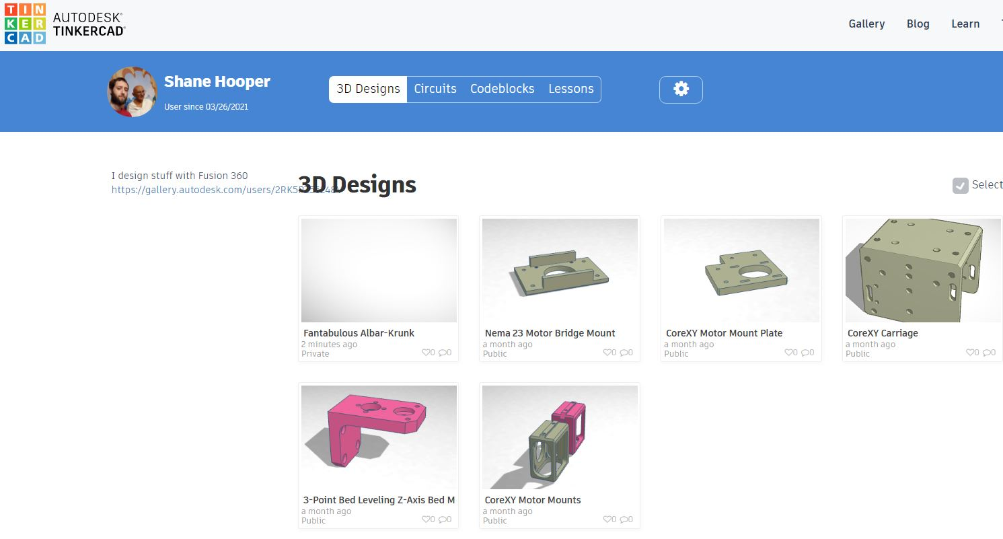

box 3d printer
3d printer models
monoprice mp select mini 3d printer v2
how to make a 3d printer
kingroon 3d printer
longer lk4 3d printer
powerspec 3d printer
3d printer desk
maker 3d printer
how to make 3d printer models
how to create 3d printer files
3d printer drawing
mod t 3d printer
3d printer test cube
make 3d printer
3d printer gif
make your own 3d printer
monoprice mp i3 3d printer
easy to use 3d printer
3d printer filament guide
ivi 3d printer
how to make a 3d printer file
simple 3d printer
x one2 3d printer
3d printer bed leveling tool
3d printer test boat
infinite 3d printer
ikea lack 3d printer enclosure ender 3
design 3d printer models
3d printer bed level test
3d printer temperature tower
3d printer aluminum extrusion
new matter mod t 3d printer
3d models for 3d printer
create 3d printer files
3d printer benchy
snap 3d printer
how to make 3d printer designs
the new matter mod t 3d printer
3d printer download designs
3d printer makeup organizer
make your own 3d printer design
fidget spinner 3d printer designs
arduino due 3d printer board
pb 3d printer
helios 3d printer
bullseye 3d printer
rebel 2 3d printer
treadmill 3d printer
3d printer graphic design
duinotech 3d printer
miko 3d printer
how to draw 3d model for 3d printer
3d printer design tools
3d printer hinge
build your own 3d printer plans
how to make a bobble head with a 3d printer
3d printer drawings download
3d printer 入門
ender 3 3d printer mods
3d printer calibration test
3d printer submarine
cubit 3d printer
ark 3d printer
3d printer designs stl
3d printer model maker
esp32 cam 3d printer
how to make a model for a 3d printer
3d printer design your own
polar bear 3d printer
master chief helmet 3d printer files
ikea 3d printer enclosure ender 3
3d printer plans download
cute mini octopus 3d printer
rubber band gun 3d printer model
3d printer arrow
3d printer arduino case
beyblade 3d printer
making stamps with 3d printer
stormtrooper costume 3d printer
3d printer pumpkin carving
wahoo 3d printer
3d builder 3d printer
smartrap 3d printer
dio 3d printer
knuckle duster 3d printer
123 3d printer
3d printer butterfly
3d printer design drawings
3d printer shredder
iphone 7 case 3d printer
piper 3d printer
3d printer mouse trap
m505 3d printer
3d printer aluminum profile
3d printer xbox controller
overhang test 3d printer
musashi 3d printer
the 3d printer experience chicago
make your own bobblehead 3d printer
3d printer file creator
draw 3d printer
best 3d printer cad
corridor digital 3d printer
prusa mendel i2 3d printer
3d printer dragon designs
3d printer for baking
3d printer orca
vertex 3d printer
colido diy 3d printer
cubebot 3d printer
2020 aluminum extrusion 3d printer
how to make a 3d printer out of legos
imp 3d printer
how to make drawing for 3d printer
ant man 3d printer
k8200 3d printer
d9 3d printer
micromake d1 3d printer
how to make 3d images for 3d printer
dms create 3d printer
3d printer file sites
pingo 3d printer
luke towan 3d printer
3d printer reel holder
3d printer for beyblades
3d printer boat test
3d printer mickey mouse
da vinci 1.0 aio 3d printer
retraction test 3d printer
3d printer anime designs
arduino 3d printer sketch
3d printer file maker
3d printer marker
how to make a simple 3d printer
arduino uno r3 3d printer
3d printer cad download
where to find 3d printer designs
3d printer ev yapımı
3d printer bed level test print
dual x carriage 3d printer
3d printer cad files download
3d printer online design
3d models for 3d printer download
plan 3d printer
zootopia 3d printer
3d printer modelleri
lamborghini 3d printer
3d printer for anime figures
monoprice mp select mini 3d printer
3d printer şase
3d printer drawer
create a 3d printer file
uw 3d printer
3d printers that work with tinkercad
28byj 3d printer
arrow 3d printer
minecraft 3d printer mod
aluminium profile 3d printer
i like to make stuff 3d printer
3d printer overhang test
3d printer raspberry pi zero
3d printer online designer
how to create a 3d printer model
3d printer simulator open source
learn how to use a 3d printer
aluminium extrusion 3d printer
3d printer shaking table
3d printers for model making
3d printer market
3d printer destiny ghost
3d printer mars colony
up box 3d printer
3d printer software
3d printer candle molds
3d printer coding language
3d printer airpods case
3d printer sewing
3d printer binder clips
3d printer desk organizer
3d printer 3d model
3d printer create and print
3d printer noob
3d printer bird house
3d printer model site
3d printer designs to download
3d printer cad drawings
cad to 3d printer
3d printer simulator game
3d printer vector 3
3d printer astroneer
3d printer autocad files
3d printer designs
28byj 48 stepper motor 3d printer
3d printer keypad
3d printer pinewood derby car
3d printer toolbox
designing a 3d printer

Related Content

3D Distributed
3D Distributed | 3D Distributed
DIY 3D Printers | Nema Motor Mounts
3D Printer Parts | WorkHorse Printer
3D Printer Kits | SolidCore
Large Scale 3D Printers | Duet3D
CoreXY | Duet Wifi Setup
Midwest RepRap Festival
12601 Bowles Rd. Conroe, TX 77304 | Houston
 | CoreXY

3D Distributed
DIY 3D Printers
3D Printer Parts
3D Printer Kits
Large Scale 3D Printers
CoreXY
Midwest RepRap Festival
All Metal 3D Printer Parts
12601 Bowles Rd. Conroe, TX 77304

